## Delivery Approach

The principal objective of having a well defined delivery approach is to control the quality and timely delivery with reduced risks. Thus we prioritized our operational model for “Quality of Service, Control of the costs and Respect for SLAs” and recommend well defined governance structure below for the successful implementation also considering the following guiding principles.

* Improve Time-to-Market and Increase Capacity to deliver new business capabilities
* Drive Architecture Standardize the Reuse.
* Continuous Improvement, Innovation and Transformation
* Reduced Total Cost of Ownership

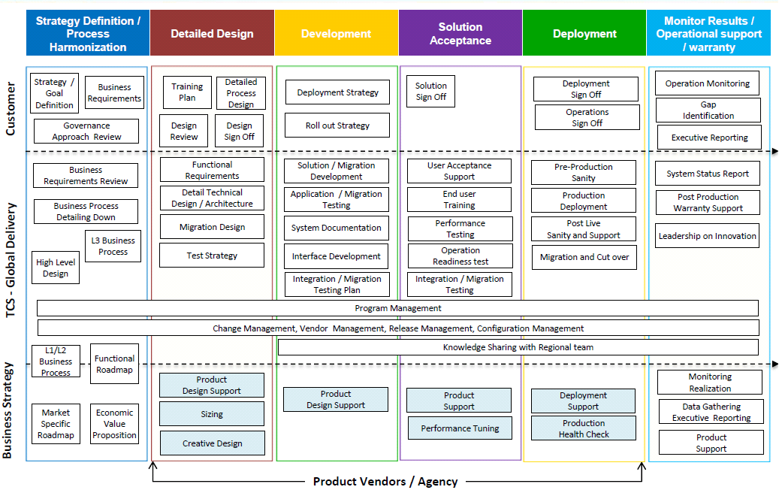

Based on these guiding principles, TCS proposes the Operational Model - “Multi-vendor customer Delivery model with largely independent work streams” as below.

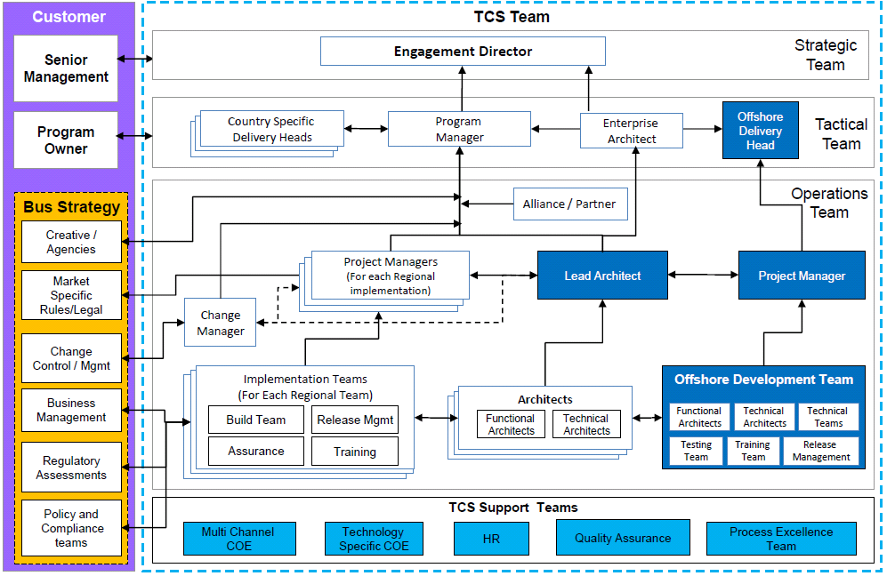

# Assurance Approach

Aligning to HPs vision of achieving the implementation of B2C & B2B packages for different geographies across the globe in multiple releases and with the vast TCS experience in similar QA engagements, TCS would like to propose an Independent Verification & Validation Testing which would provide End to End QA Services for the successful and timely completion of the project.

The Independent Verification & Validation Testing will ensure the Synergistic Independence Model is followed in between the System Integration team & the QA team.

Below figure reflects the HP Objectives and the Key TCS solution elements along with the benefits we bring to HP while performing the Quality Assurance for multiple releases.

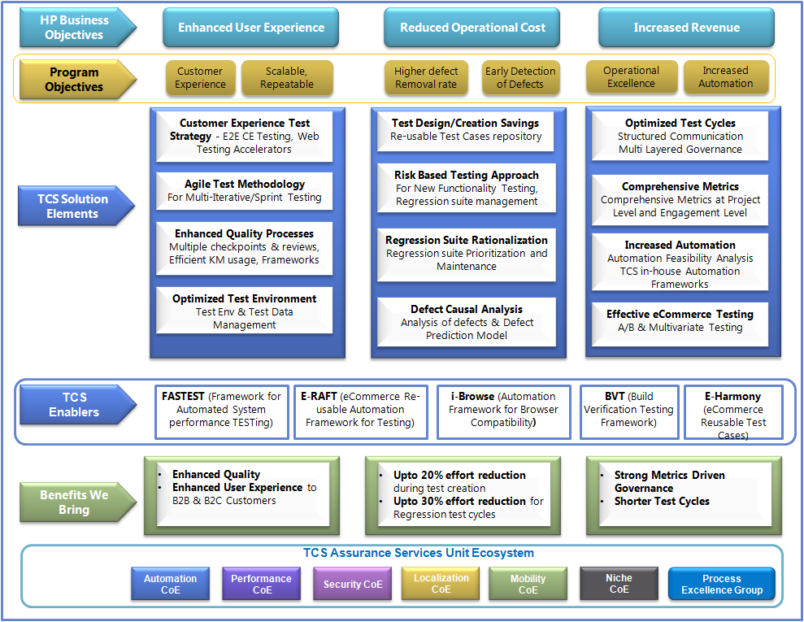

Figure 28: HP Objectives and TCS Solution Elements

TCS analyzing HPs logical architecture and integration touch points has arrived at a best possible test solution as detailed below. The test approach encompasses TCS’ experience, best practices and learning’s from similar integration and multi-channel eCommerce projects.

Testing Solution comprises of the following key elements:

1. Setting up an Independent Verification & Validation Team having Synergies with SI
2. Proven Testing Methodology
3. Robust and Customized Test Environment Solution for eCommerce Implementations
4. Performing Functional & Non - Functional Testing ensuring better coverage and quality
5. Strong Governance Model with Metrics and Dashboards
6. TCS Value Proposition - TCS Testing Tools, Enablers and Best Practices for eCommerce implementation

**Independent Verification & Validation Setup & Synergistic Independence with SI**

TCS Proposes an Independent Verification & Validation team to execute Testing Services for HP’s eCommerce transformation program. Below figure captures the flow of activities between the various stakeholders at Sprint/Release Level for both Release 1 and 2 in parallel.

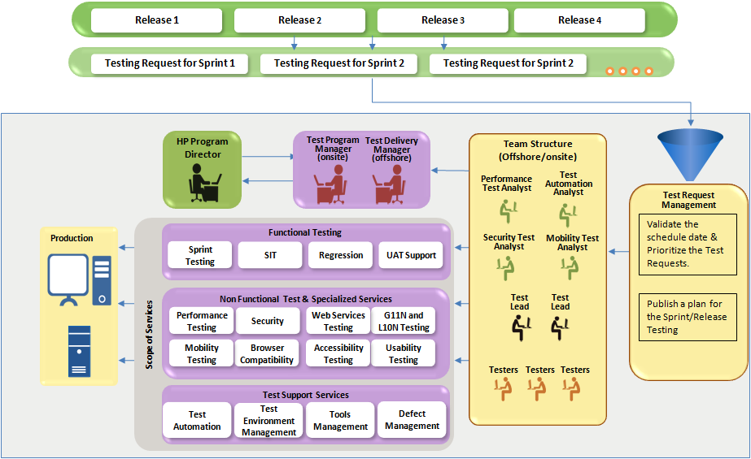

Figure 29: Independent verification and validation team

Synergistic Independence of this team with System Integrator will ensure

* Testing team will leverage the knowledge from TCS SI partner to build and reuse their tools appropriately to accelerate integration test planning and execution.
* Testing will leverage TCS SI partner to reduce defect fix turn-around time to accelerate test execution
* Team will leverage SI partner’s functional knowledge to review the test coverage.

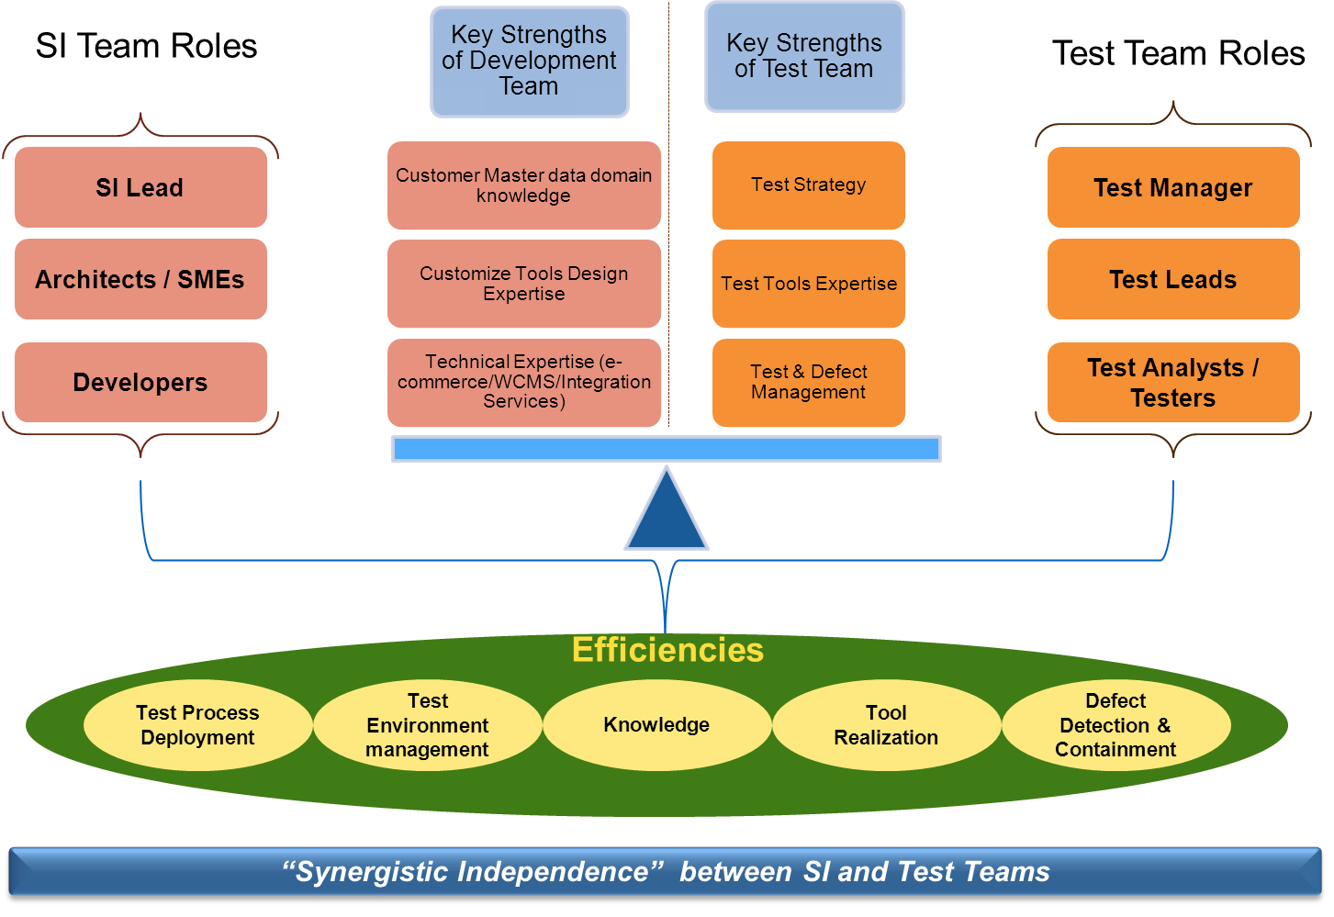

Figure 30: Synergy between testing and development team

**Testing Methodology**

TCS proposes Agile methodology for testing which would ensure test effectiveness at Sprint Level as well as Release level of Testing. Test Methodology has been covered in detail under *Test Methodology (Section -7*)_of this document.

**TCS Test Environment Solution**

TCS understands that Test Environment Setup & Management activities will be performed by the Supplier along with the other QA services. Keeping in mind the Program Overview, where Sprint & Release level Testing needs to be performed and also there are parallel releases (with different Functional & Non-Functional Testing’s to be performed) **Test Environment Setup, Management & Provisioning** will be a key aspect for the success of training program.

Test Environment Solution has been covered in detail under *Test Infrastructure requirement (Section-3)*

**TCS Proposed Testing Solution**

Table 7: TCS Testing capabilities

|  |  |  |  |
| --- | --- | --- | --- |
|  | Proposed Testing | TCS Capabilities | TCS In-House Accelerators / Assets |
| 1 | Functional Testing (E-Commerce) | * 3000+ test professionals &1000+ Domain Consultants * 76+ Customers worldwide * 6 of Top 10 US Retailers,3 Top US Pharmacy Retailers, 5 of Top 10 UK Retailers * 15,000+ professionals working on IBM Technologies | * **E- Harmony:** Comprises major modules of customer Profiling, Browse & Search, Merchandising and Checkout Covers nearly 60-70% of reusable test scenarios. * **e-RAFT :** Reusable Automation Framework for Testing   specialized for eCommerce applications  enables to merge both automation and manual  Testing into a single step. Powered with  Automated test accelerator package provides 40% effort reduction over traditional automation approach.  **BVT** – Keyword Driven Automation Framework built on top of HP QTP for Build Verification Testing **(BVT)** |
| 2 | Performance Testing | * 350+ Automation/Performance Test Professionals * 300+ HP certified professionals | * **FASTEST** - Framework for automated system performance testing and reporting * **WANem** - emulation tool to simulate real life network latency during performance tests * **Transaction Profiler** - Transaction analyzer for performance tuning |
| 3 | Security Testing | * Over 20+ projects executed in eCommerce security domain * 400+ Consultants across Niche Security consulting areas * Certified associates in Security Domain - CISSP, CISA, CISM, ISO and CEH. | * TCS SSA process- Helps in establishing a standard process for Application Security testing * Essential Test Scenarios - Helps in ensuring coverage of Top vulnerable areas for Top 10 vulnerabilities * Expertise Data Validation/Vulnerability, PCI/PII , Fraud Detection Testing Techniques |
| 4 | Web Services Testing | * 1000+ associates working on SOA Testing * Expertise on HP Service Test , CA LISA, Greenhat Tester, Parasoft SOAtest, soapUI * 25 + Customers engagements leveraging various SOA Tools | * **SOA Testing framework** developed for data driven testing of SOAP web services * Reusable component repository which includes components that can integrate with the SOA Testing tools to extend and customize the SOA Testing Tool’s features |
| 5 | G11N Testing | * 3500 person months experience in I18N Testing * 1000 person month Experience in Localization L10N Testing | * Internationalization Questionnaire * Design Review and Env Setup Checklist * I18N and L10N Checklists * Cultural and Cosmetic Checklist * **Harmony for G11N/L10N Test Cases**: Reusable Test Cases |
| 6 | Mobility Testing | * 12+ years of Mobility experience with 190+ Customer engagements * 1100+ mobility testing associates skilled in various smart devices, mobile OS platform & Simulator testing * Alliances with DeviceAnywhere and Perfecto Mobile | * TCS in-house automation framework Hy5 TestTM |
| 7 | Browser Compatibility | * Over 150+ engagements * Experienced people in consulting, support and training | * **I-Browse** tool developed for Cross-browser compatibility testing |
| 8 | Accessibility | * Experienced consultants, test analysts in all the tools and guidelines * Training, account set up, delivery support | * Reusable test cases from WCAG 2.0 guidelines and remediation |
| 9 | Usability Testing | * Over 50+ Engagements worldwide for Usability Testing | * 100+ test cases in e-Commerce Search and Browse- Navigation and Consumer Profiling * 60+ points checklist for mobile device designs to evaluate navigation, content, presentation, and interaction * 60+points Heuristic Review checklist to evaluate applications against essential principles of user-application interaction |

TCS Testing Solution for various types of testing is described in detail below:

**Functional Testing**

TCS Testing team will perform Functional Testing of the business functionality for the eCommerce implementation. TCS will study the functional requirements and create test cases to test the entire requirement. We will also utilize the knowledge base in e-Harmony to create new test cases to fill in the gaps, prepare traceability matrix to ensure 100% requirement coverage. These test cases would also form the basis for regression test packs.

TCS’ well matured Risk Based Testing approach can be pragmatically looked at leveraging when there are slippages with respect to time or cost.

**Performance Testing**

TCS understand HP’s Performance Testing requirements as below:

* Complex data flow inhibit rapid change, Data integrity issues in the product, catalog and content management area – Load testing with large number of user can help in early identification of issues and early resolution.
* eCommerce store performance must be measured and base lined. As per a survey in less than 4 seconds user makes a decision to stay at the page or leave it.
* As per available statistics Orders as a percentage of total number visits is a very small number. It could be improved by enhancing website performance. Customer is more likely to make an order at high performance website than otherwise.

A report would be prepared for each performance testing iteration. Report would have application response time as would be experienced by end users for the current application state. If application response time fails to meet defined Service Level Agreement (SLA) then a defect would be logged for particular scenario. Developers would fix such defects in future iteration and a retest would be done after the fix. If application response time meets defined SLA then defect would be closed and subsequent Performance Testing execution will be carried out.

Key parameters for HP which performance testing approach will consider are:

1. Volume of Data Transaction: The volume of data transaction is dependent on both the number of users as well as parameters given as input to the automated scripts especially in search scenarios. This parameter is vital in determining the threshold of data beyond which the service behaves in unexpected ways.
2. Concurrency: The test scenarios to reflect real time usage of the application as is expected in production
3. Latency: Since end user response time is a function of performance of the service, bandwidth in the network and other communication overheads, the associated times must be captured
4. System utilization: Utilization levels of CPU , memory, disk and related system parameters must be captured
5. Critical Business Flows: Transactions for performance testing will be identified based on their business criticality, from revenue point of view, most accessed transaction etc.
6. Failover Testing OF servers: All the server parameters should be closely monitor and checked for a failover criteria to ensure zero downtime during the performance test execution.
7. Improper baselines or benchmarks: Application in its entirety will be performance tested & benchmarked with respect to maximum number of concurrent users that it can handle, its throughput, resource utilization.

* Verify and detect a failover condition & verify the alerts configured upon a failover condition
* Verify hot failover, failover to the standby instance shall occur without human intervention

TCS would perform the Load test, Stress test and Volume Test as a part of performance testing.

Understanding the heavy uses of the mobile application, TCS recommends an early start of Mobile applications. Following are the performance test focus areas:

· Applications behaviour on various platforms /devices

· Application crashes & Memory leaks

· Monitor inefficient resource uses

· Variations in Response times

· High memory and CPU consumption

· Application loading response time on Mobiles

Few Recommended tools list for Mobile Performance Testing are:

· WANEM (TCS Proprietary)

· FASTEST (TCS Proprietary)

· HP Loadrunner (Commercial)

**Security Testing**

Security testing will ensure that the overall solution will meet the non-functional requirements specific to security of the application. The key elements to be tested for the 15-20 web services expected to be in scope are:

1. Compliance to PCI standards
2. Authorization
3. Authentication
4. Confidentiality
5. Fraud Detection

**Web Services Testing**

TCS proposes the use of HP Service Test for SOA Testing and HP Service Virtualization for Service Virtualization.

HP Service Test will be able to interact and perform testing on the following upstream, downstream and middleware products and components in the HP eCommerce Transformation program which will come in scope of SOA testing.

* TIBCO Web Services and Interfaces (Middleware)
* CRM Services (Downstream/Upstream)
* Content Services (Downstream/Upstream)
* eCommerce B2B Transactions
* Databases (Downstream)

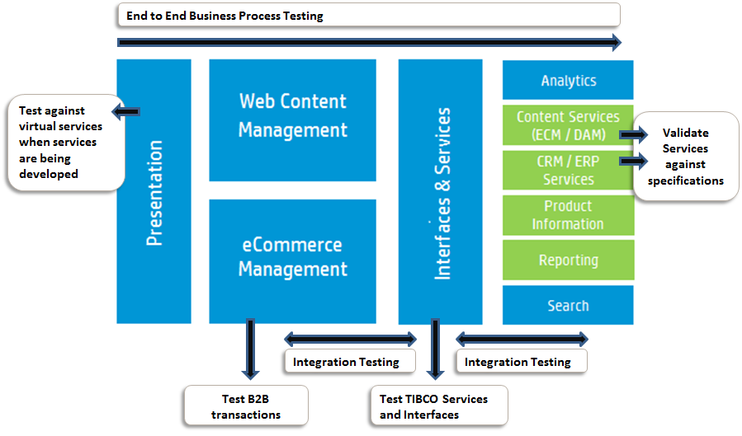

Figure 31: Webservice Testing

Testing of Services in isolation is achieved by simulation of input request messages from service testing tools and by mocking the downstream services using service virtualization tools. Testing integration of services is done on a continuous basis at various integration points within a service. It is recommended that integration testing starts only after the source and target systems which integrate are available. If any systems are unavailable during the integration testing phase, Service Virtualization will be used to overcome this constraint. Once the validation is complete at all layers, end-to-end business process testing is carried out between different systems.

**Globalization Testing**

TCS end to end globalization strategy will include the following:

1. **Internationalization testing** carried out on application. During I18N testing we check how well the application adapts for a given locale or language, which allows to verify that localization does not break globalized and localizable resources
2. **Localizability testing** is performed on pseudo localized build in parallel with internationalization testing. The purpose of localizability testing is to verify that the UI of the program being tested can be easily translated to any target language without re-engineering or making code modification
3. Instead of doing functionality testing for each localized version of an application, TCS will carry functionality test execution on globalized build. This will ensure that functionality has been globalized for core product.
4. Localization testing verifies how well the product has been translated into particular target language. Localization testing requires limited technical expertise; instead, language proficiency becomes the major requirement for the tester.

*So prior to the application is localized for the first time the design features are reviewed and the localizable using pseudo localized.*

**Internationalization testing** will be performed before the first pilot language is released and it is a onetime activity.

The test environment and test data of this whole approach is based on multiple parameters .Test environment can be the windows MUI, localized OS or virtual labs for various OS in multiple locales .Test data will include the production data, Unicode strings and reusing the functional test data as well.Non English configuration and non ASCII data is used from the starting of the Life cycle. It helps identify the underlying code is locale sensitive and can perform as expected in different language environments.

**Internationalization testing Approach**

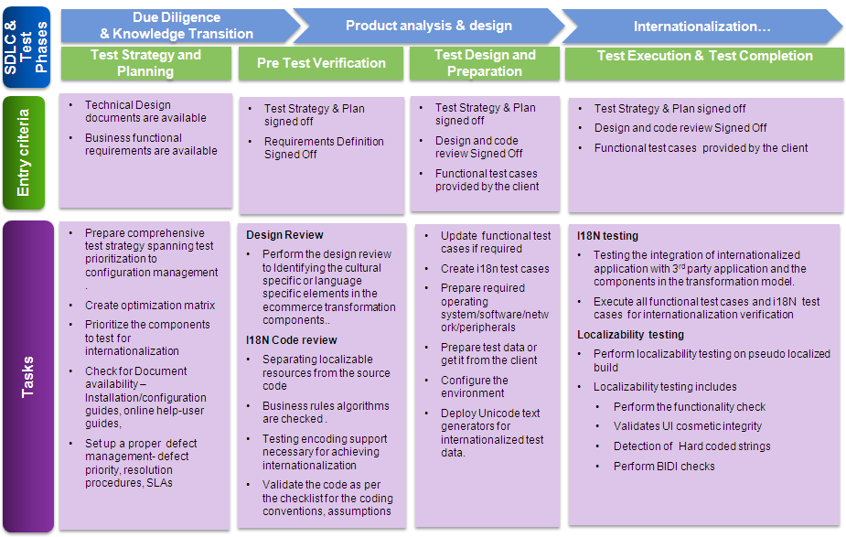

Figure 32: Internationalization testing approach

**Localization testing Approach**

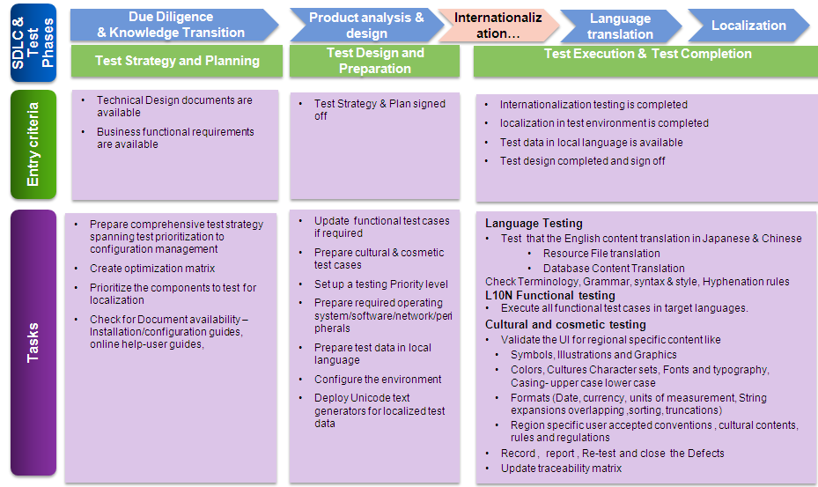

Figure 33: Localization testing approach

For Multi-language testing TCS will leverage the below:

1. TCS local hires across various countries – One of the byproducts of TCS local hiring policy is a large community of foreign language speaking personnel. TCS also has a Foreign Languages Initiative (FLI) team which comprises of associates belonging to different parts of the world.
2. Translation Verification using Automation – Key translation verifications will be automated

**Mobile Testing**

Aligning to the development solution of the mobile application of HP eCommerce, TCS has identified the below testing scope

Table 8: Mobile testing scope

|  |  |
| --- | --- |
| **End to end functional Testing** | 1. Testing will be done for all the services in different mobile apps 2. All the integration points will be tested 3. Real time alert messages for different transactions to mobile |
| **Gateway** | 1. For all the B2B and B2C transactions accounting entries will be matched from the applications and gateway layer 2. Synchronization between the mobile app/ web services and gateway will be checked |
| **Integration points** | 1. Integration Testing will be done with all the third parties after HP integrated with them. It includes aggregator, payment gateway, ERP solution and CRM 2. Stubs will be prepared to simulate the different external systems. 3. Message log will be matched from gateway portal and real time mobile app messages |

Support needed from HP

1. HP will provide the security clearance to access necessary systems and environments from a Testing point of view
2. Subject Matter Expert (SME) will be available to provide support for key business issues by TCS mobile testing consultants, at agreed checkpoints

TCS will perform a feasibility study on leveraging TCS in-house automation framework Hy5 TestTM for mobile testing to complement the automation in addition to automation achieved using QTP

**Browser Compatibility Testing**

TCS will employ a three phased approach for Browser Compatibility testing

1. Engage & Establish Phase
2. Refine & Realize Enterprise Wide
3. Fully Managed & Automated

TCS will utilize its in-house **i-Browse** framework for automation of the testing process.

* Focus on reusability of test steps and test data to create components and the same could be utilized for different test cases
* Creation of automation script will be done once and reusable for different combinations of browsers and OS
* Automation experts will be responsible for Environment set up
* Creation of Test Strategy document
* Selection of defect tracking tool and create new project for different releases
* Maintain version control for automation scripts in configuration management tool
* Kept ready with WSR, DSR, MSR, Issue Tracker and other supporting docs
* Follow defect life cycle
* Retesting of defect would be done through automation scripts
* Same automation script would use in regression cycle

**Accessibility Testing**

Accessibility testing will be performed to validate and certify the website for accessibility Compliance. Manual Testing, Browser Compliance Testing, Automated Testing, User-centered Scenario Testing are various services and the best suited for HP will be agreed after discussed with HP business.

The key features to be tested for HP solution are

* Audit and certification of the applications
* Compliance with latest accessibility Guidelines

TCS will require knowledge from HP for the Compliance Regulations for each of the Countries where Portals will be deployed.

**Usability Testing**

Effectiveness, Efficiency and Satisfaction are key contributors to Usability of a system. TCS QA will cover the following aspects of Usability

1. The visual appeal, readability of the pages, balance between text and images
2. Navigation with minimum number of clicks
3. Perception of Privacy of information, ability to limit what personal information is shared
4. Site performance in loading pages, consistency of speed
5. Level of security in completing transactions, verification of task completion, cross channel experience in transacting

**A/B Testing** and **Multivariate Testing (MVT)**

TCS will perform A/B and Multivariate Testing for enhancing effectiveness and relevance of content across HP’s online channel and increase the content relevance through segmentation, targeting and automated personalization. TCS will Test content on site, in email and in display ads. TCS MVT allows for testing many elements and variations with smaller traffic requirements and fewer combinations

**User Acceptance Testing Support**

User Acceptance testing will be owned and executed by HP. TCS will have a UAT coordinator to work with HP UAT team to provide required support for UAT testing. UAT coordinator will help

1. Back end test data configuration or setup
2. UAT test readiness
3. Support defect coordination during UAT phase

**Regression Test Approach**

HP e-commerce transformation program will be covered in multiple releases based on the geographies for which a particular release is done. Within the releases, there will be Sprint level development & testing activities which will be conducted. This makes Regression Testing a very important aspect which will be performed at Sprint & Release Level.

TCS Regression testing solution aims to maximize Test Effectiveness & Minimize the Cost and Effort involved in ensuring the Quality Assurance of the Portals.

Based on the functional, non-functional test cases executed in Sprint Cycles for one release Regression test pack will be created the series being executed in parallel.

Below diagram showcases TCS Regression Testing Methodology

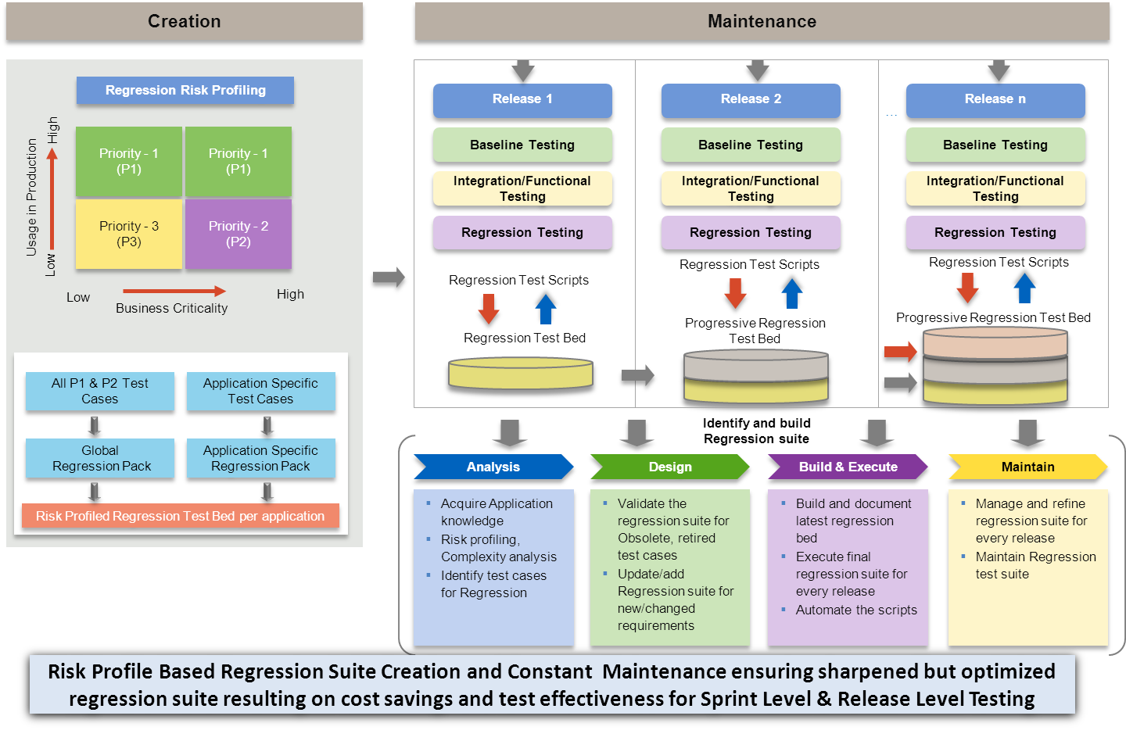

Figure 34: Regression test methodology

**Test Metrics**

TCS recommends the following mandated testing metrics for the testing projects:

* T9 – Nine mandated metrics for Manual testing
* T5 – Five mandated metrics for Automation Testing
* T3 – Three mandated metrics for Performance testing

These metrics will be mutually discussed with HP and tailored to the Program needs. Benefits of Mandated Metrics:

* Provides effort spent at each phase of testing and help estimating the same for similar projects
* Provides % automation Completed and % manual test cases
* Measure ROI (Return on Investment) and cost saving due to Test Automation Vs. Manual Testing
* Measure efforts required for automation design, development and maintenance
* Measure the quality of testing and stability of software
* Identify % gap between the requirements and test cases designed/executed
* Measure productivity of the testing team/individual at various phases of testing
* Identify % gap between the actual Vs. planned test cases designed/executed

Following diagram shows the dashboard for metrics collection and reporting:

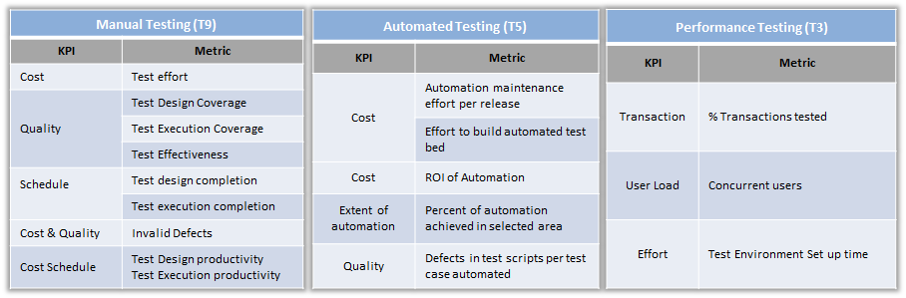

Figure 36: Testing Dashboard

**TCS Value Proposition**

TCS backed with its three decade long experience of providing testing services to customers globally, will bring to the table its in-house Testing Assets and Accelerators, Best Practices for HP’s eCommerce Transformation Program as Value Proposition.

1. **TCS Assurance Tools and Accelerators** - TCS Proposed in-house Assets are listed in **Section Supplier-Provided Software & Frameworks**
2. **TCS Assurance Best Practices:**
3. **TCS Shift Left Approach**: Please refer section “Assurance Methodology” of the Response for more details on Shift Left Approach.
4. **Release Based Testing:**

TCS test team will have a retrospective meeting post every major release and this discussion would be leveraged to discuss on the best practices, lessons learnt during the release. This meeting would be used to identify high value and utility best practices so that they can be shared across and continued further in the upcoming releases. This meeting would also be used to discuss the lessons learnt and establish the process controls and solicit from the stake holders for implementing the same.

Apart from the above, TCS test team would perform below activities as part of the release closure activities.

* Perform Causal Analysis of defects
* Update Regression Suite based on the new functionality added, defects found, causal analysis findings
* Update Knowledge base

***Perform Causal Analysis of Defects –*** *Some more details*

Defect Causal Analysis is aimed at **defect prevention** and done from the below perspectives

* Phase Leakage prevention (Unit test scenarios slipped to Integration Testing, Integration Testing defects slipped to UAT, Production)
* Test Coverage Enhancements (Test Case, Test Scope, Test Data, Test environment enhancements)
* Process Quality Improvements (Requirements Stability, Test Environment Quality, Build Management etc.)

Defect Causal Analysis is performed at the below stages

* Release to Release
* IT to UAT and UAT to Production
* Frequently occurring issues
* Application/Area wise analysis

1. **Traceability Matrix**

Traceability enables to determine the relationship between different requirements, tests. It also allows to link defects to the test cases and thereby achieving an end to end traceability across STLC. (Sample below)

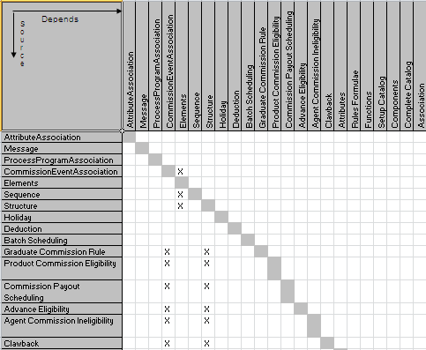

Figure 37: Sample Traceability

[***Bidirectional Traceability***](http://csqa.info/bidirectional_traceability#comment-300):

Bidirectional traceability is the ability to trace both forward and backward (i.e. from requirements to end products and from end product back to requirements).

***Benefits of Traceability Matrix:***

* Easy to track, if any test case is not being mapped to the requirement or missing functionalities
* Test cases can be easily identified if there is any change requests for a particular requirement
* Ensures end to end testing coverage
* Helps in identifying the redundant test cases
* Help in validating that the test case is developed based on the requirement

Apart from the above mentioned; TCS Quality team has several process hand books that would embody all the best practices learned across the organization in to Process Hand Books and Reusable assets. Care is taken to not to share any confidentiality related information.

# Infrastructure Requirements

Table 9: Environment Requirements

|  |  |  |
| --- | --- | --- |
| Environment Type | Number of Environment(s) | Purpose |
| **Development** | 2 | Two environments per release. One environment for Development of the ongoing sprint and the other for supporting testing of the previous sprints |
| **System Integration Testing (SIT)** | 2 | Different components will be integrated in SIT environment for integration testing. Two SIT environments required to support two consecutive sprints. |
| **UAT/QA** | 1 | Testing by HP IT Team |
| **Training** | 2 | One environment for training the Trainer and the other for Trainer to train the trainees |
| **Pre-Production** | 1 | Staging environment. The environment will be planned with close to 50% capacity of Production capacity to carry out performance tests for releases after go live.  Data migration Tests will be executed on this environment |
| **Production** | 1 | 1.Performance Testing environment  2. Go Live environment |

An effective ecommerce site must scale with the number of users, respond reliably and quickly, and optimize its use of bandwidth. For effectively plan the capacity an exhaustive list of sizing factors need to be considered along with the future scalability requirements per region and country. Considering the number of factors affecting capacity planning and cost impact, TCS recommends to carry out a detailed sizing exercise for Production and Pre-production environments during the implementation phase.

TCS proposes to commission the following environments for the eCommerce transformation program for each country. Each environment can be used for more than one purpose.

The environments detailed will be scratch and build environments, which will be optimized for reuse for different countries, regions & Line of Businesses. The reuse will be determined based on the rollout timelines for each country, with in a region and deployment options e.g., common instance across some of the countries with in the given region. Therefore, deducing the exact number of environments per each release will be carried out based on the requirement analysis phase.

The following table provides the Hardware requirements of the environment s except for Production and Pre-Production environments. The environment details are provided in terms of computing resources. The same set of resources can be configured on a virtualized environment. The environment column indicates the environment(s) that can be built on the given hardware.

Table 10: Sizing information

|  |  |
| --- | --- |
| Environment | Hardware Details (Initial Assessment) |
| **Development 1 & 2** | Apache Web server : Intel Xeon dual Core, 1CPU 1.2GHz, 12 GB RAM  Commerce Server and Contact Center : Intel Xeon Quad Core , 2 CPU,2.4GHz, 32GB  DB server: Intel Xeon Quad core, 2CPU ,2.4GHz, 32 GB RAM  Autonomy TeamSite: Intel Xeon Quad core, 1CPU, 2.4GHz, 24 GB RAM  Autonomy IDOL : Intel Xeon dual Core, 2CPU, 2.4GHz, 24GB RAM |
| **Training 1 & 2** | Apache Web server : Intel Xeon dual Core, 1CPU 1.2GHz, 8 GB RAM  Commerce Server and Contact Center: Intel Xeon Quad Core , 2 CPU,2.4GHz, 16GB  DB server: Intel Xeon Quad core, 2CPU ,2.4GHz, 32 GB RAM  Autonomy TeamSite: Intel Xeon Quad core, 1CPU, 2.4GHz, 16 GB RAM  Autonomy IDOL : Intel Xeon dual Core, 2CPU, 2.4GHz, 16GB RAM |
| **Systems Integration Testing**  **&**  **User Acceptance Testing** | Apache Web server : Intel Xeon dual Core, 1CPU 1.2GHz, 8 GB RAM  Commerce Server and Contact Center: Intel Xeon Quad Core , 2 CPU,2.4GHz, 16GB  DB server: Intel Xeon Quad core, 2CPU ,2.4GHz, 32 GB RAM  Autonomy TeamSite: Intel Xeon Quad core, 1CPU, 2.4GHz, 16 GB RAM  Autonomy IDOL : Intel Xeon dual Core, 2CPU, 2.4GHz, 16GB RAM |
| **Pre-Production** | To be analyzed and sized during implementation |
| **Production** | To be analyzed and sized during implementation |

# Methodology

TCS’ approach to project delivery of the Solution for the required components has a strong focus on all aspects of quality management. The quality objective of TCS is to bring continuous reduction in cost of quality. All TCS initiatives are directed towards defect prevention and improvement practices to meet this objective. Reduction in cost of quality provides benefits of on-time, on budget project delivery and year on year productivity improvement to the customer.

To achieve this at an enterprise level, TCS has evolved an Integrated Quality Management System (iQMS), which addresses quality assurance practices for all types of projects including application development and support. iQMS is an integrated approach to implementing quality practices of world-class benchmarking models like ISO 9000, ISO20000, CMMI, PCMM, Six Sigma, ISO 27001 and ISO 14001. The delivery and project management methodology for this program will be based on iQMS, which will form the backbone for all activities undertaken by TCS on all the projects.

TCS understands the complexity of eCommerce transformation in HP for multi-country rollout and will adopt tailored iQMS processes for this engagement.

## Project Execution Methodology

TCS has rich experience executing programs using various development methodologies such as Waterfall/Modified waterfall, Agile, Spiral and JAD. In line with HP’s requirements, TCS plans to adopt agile methodology for this engagement. TCS understands the market dynamics and the quick time-to-market needs in the digital channel initiatives and commits to deliver the eCommerce transformation adopting agile methodology and best practices to ensure the successful rollout catering to HP’s multi-country vision. TCS strongly believes that early preview to business and IT is required for transformational initiatives of this nature. TCS projects that have followed agile methodologies have successfully blended the onsite-nearshore-offshore delivery model adopting the best practices from TCS’ Integrated Quality Management System (iQMS™).

* + 1. Agile Methodology

TCS will adhere to the B2C deployment for APJ countries, US, EMA, Rest of the world and B2B rollout spanning across four releases as proposed by HP. In order to achieve optimal performance of the agile delivery, following are pre-requisites identified for the successful adoption of agile in HP scenario:

* While agile is adopted in dynamic business environment with evolving requirements, finalization of business processes, and priorities for the eCommerce transformation is recommended
* Finalized high-level solution architecture
* Business involvement to ensure frequently changing or abstract requirements needing continuous collaboration between business and IT teams are well managed during execution
* Effective management of dependencies such as creative designers
* Development environment can support frequent continuous builds and automated testing
* The production environment supports incremental software releases
* Smaller team size and ideally co-located
* Common environment for requirements management and testing
* Infrastructure and robust environment planning

The eCommerce platform for HP gets built incrementally by taking inputs and changes. As part of agile development life cycle model, each of the four production releases will be split into multiple internal agile releases. The plan is to have a global foundation release which will be built predominantly typically during the initial Sprint cycles that establishes the end-to-end architecture and an incremental sprint methodology for later releases. Each internal release in turn will have multiple sprints of about 4 weeks in which cross country and cross functional teams will participate. The Scrum master governs and manages the sprint.

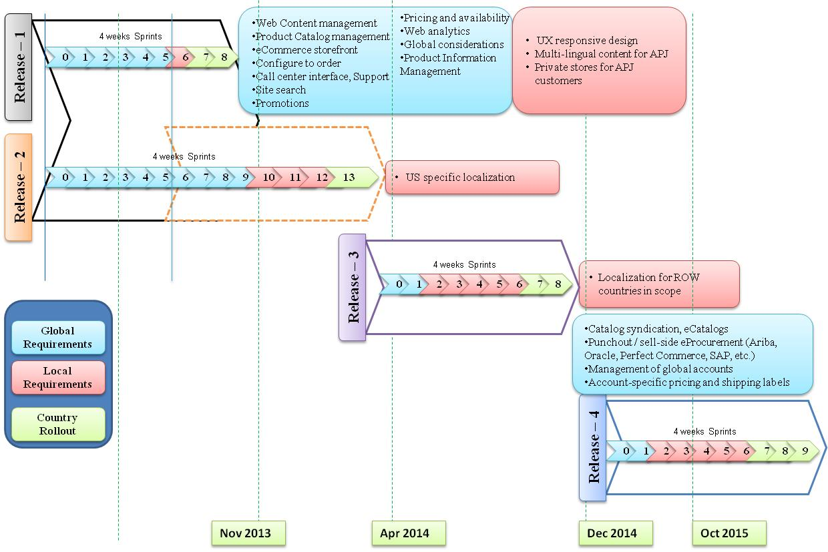

Figure : Approach for Global and local development

With profound analysis of the eCommerce current state requirements provided by HP combined with multi-country implementation requirements spanning across multiple sprints and parallel releases, TCS has come up with an indicative high-level plan for the execution of various capabilities within Sprint as illustrated below:



Figure : High-level Sprint Plan for release-1 and release-2

Sprint planning within each release will be designed and built for various capability areas incrementally in the order of building the foundational elements so that subsequent sprints can leverage and build further. For example, as depicted above, Sprint-1 builds Storefront/Ux responsive design/Basic product catalog in ATG, the following table depicts various activities that be performed within the Sprint considering storefront/basic product catalog capabilities:

|  |  |  |  |
| --- | --- | --- | --- |
| Release-1 | Capability | Phases | Sprint activities |
| Sprint-1  Global Sprint | Storefront, basic product catalog | Business requirements | Research products, request consultation, manage consultation – Business/IT workshops |
| Architecture | * Build product hierarchy structure * Global product catalog structure * Design common data model * Build integration architecture for teamsite and ATG * Design services for product catalog sync-up, inventory check |
| Functional requirements | * Browse products * Compare products * Check availability * Compare products * Determine product compatibility * View product details |
| Design / Creative UI | * Receive creative design from HP * Screen mockups and demo to business – Business collaboration * Design product template in teamsite * Design interface between teamsite and ATG for product sync-up (E.g DCR upload) * ATG BCC to design compatibility, cross-sell/up sell, association of accessories etc. * Receive Interface specs from HP for building integration inventory systems and master product catalog management system |
| Development | * CSS, HTML5 development for front-end * Use teamsite for product details, images, product documents, videos uploading * Configure BCC to incorporate product compatibility rules * Build services in ATG and in teamsite for product sync-up as per the interface specs * Build interfaces from ATG and integration layer components for interacting with inventory and other back-end systems |
| Sprint-2 |  | Quality Assurance | * ATG and teamsite component testing * System integration testing |
| Sprint 6 – Sprint – 7 |  | Localization | * Build and testing for Country-specific localization |

Each sprint will be incrementally built using agile principles and product backlog will be maintained and executed in subsequent sprints. The following figures provide the high-level plan TCS is considering for release-3 and release-4. The detailed Sprint plan will be prepared on similar lines for other sprints.

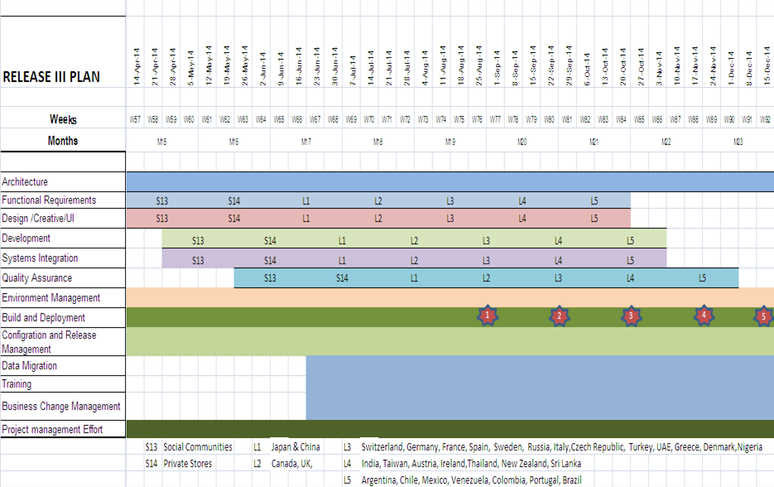

Figure : High-level Sprint plan for Release 3

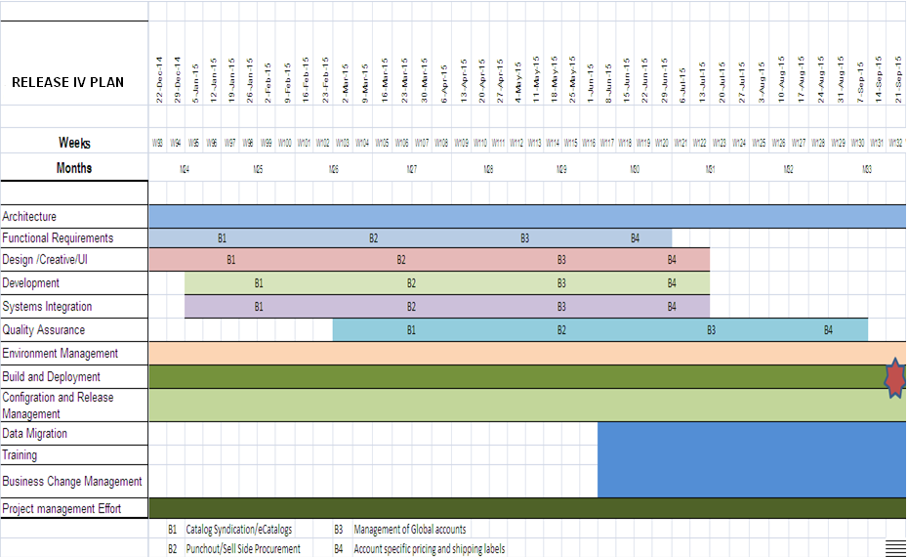

Figure :High-level Sprint plan for Release 4

Key principles in our implementation approach are as follows.

* Break down system features into manageable chunks that small teams can create in a few months
* Always have a product you can theoretically ship
* Maximize communication, minimize overhead and maximize sharing of tacit, informal knowledge
* Adapt to technical or marketplace (user/customer) changes
* Build executables frequently for inspection, adjustment, testing, documentation and improvement

The following picture illustrates how the various sprints will be planned, executed and how the product backlog (or requirements) gets implemented in a SCRUM methodology.

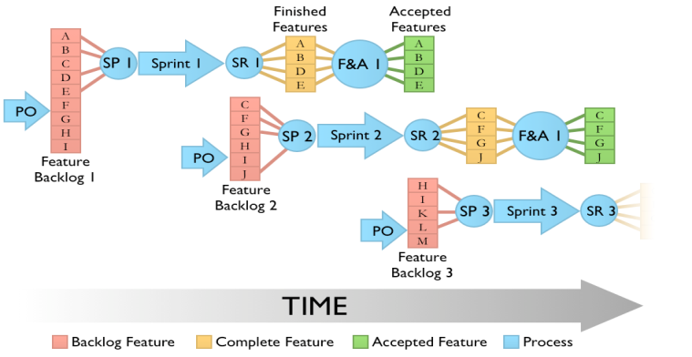

Figure : Sprint execution

TCS will adopt onsite/nearshore/offshore methodology for executing this engagement. The following diagram illustrates various phases which will be performed at onsite/offshore locations.

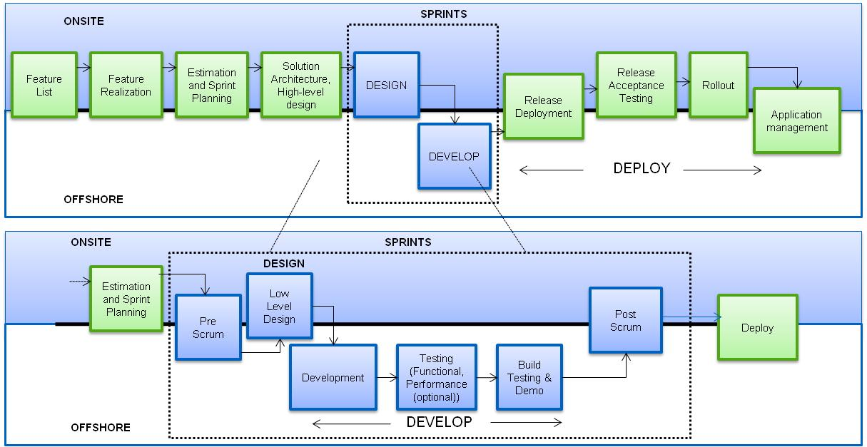

Figure : Sprint Methodology in Onsite/Offshore model

Based on the successful agile practices adopted in various engagements, TCS recommends the requirements feature list, solution architecture and high-level design are finalized prior to the commencement of Sprint. At the start of each Sprint, a Sprint Planning Meeting is held during which the Product Owner prioritizes the Product Backlog and the SCRUM Team selects the tasks they can complete during upcoming Sprint. Core activities in Sprint execution in general involves define and development phases and planned as below.

* + 1-2 weeks - Requirements analysis, design, contract definition & documentation. Fixing of testing observations from the last sprint is also done in this phase.
  + Week 3 - component development
  + Week 4 –component testing. Starting from the third sprint, a demo of 1-2 hours to get user buy-in and indicate value delivered will be planned

Quality assurance can be planned as the 30 days or 90 days Sprint cycles depending on the effectiveness it will bring to the HP scenario. At the end of each Sprint the team demonstrates the completed functionality at a Sprint Review Meeting.

A periodic meeting will take place between the TCS delivery manager and the project steering group to provide status of the project. The communication process (format, frequency & method) will be documented in the Communication Plan & approved by all stake-holders (including third party) during definition stage and will comprise of weekly & monthly checkpoint reporting with a status report depicted for cost, timeline & risk.

TCS plans to consider Singapore as the onsite location for global and Austi, US as the regional delivery location while India will be the offshore center. The activities that require meeting / workshop with various Scrum teams, business users for capturing high level requirements, design details, architecture decisions are to be carried out from on-shore location.

The combination of all the above will ensure on-time, on-budget delivery of a fit for purpose solution.

* + 1. SDLC Implementation approach

TCS follows a well-defined process during different phases of the project. The essence of the process is a structured method of process control using checklists of activities with specific Entry criteria, Tasks, Validation procedures, and eXit criteria (ETVX), in conjunction with a focus on process management including defect prevention.



Figure 46: Implementation phases

Considering the complexity and variations catering to local markets, it is essential to take more collaborated approach in executing this engagement. The following table provides a view of HP stakeholder involvement in the various phases of the eCommerce transformation initiative along with the deliverables created from the phase. Indicative roles are provided for HP stakeholders and the exact role mapping will role in HP organization would be done during the start of the engagement.

Table 13: HP and TCS involvement for program phases

|  |  |  |  |
| --- | --- | --- | --- |
| Phases | Customer Stakeholders | TCS Stakeholders | Deliverables |
| **Discovery and baseline** | Program Manager, Business Analyst, Key Business Stakeholders, Architect, Test Manager, Operations Manager, Service Management Lead | Program Manager, Business Analyst, Architect, Solution Designer, Test Manager, Operations Manager, Practice Consultant | * Business requirements (Global, Local) * Business Processes * Project plan * Traceability document |
| **Requirement Gathering** | Program Manager, Architect, Business Analyst, Test Manager, Development Managers, Operations Manager, Service Management Lead | Program Manager, Architect, Business Analyst, Requirements Manager, Test Manager, Development Leads, Operations Manager | * Functional requirements and feature list document |
| **Solution Architecture** | Program Manager, Architect, Development Managers, Operations Manager, Test Manager | Program Manager, Architect, Business Analysts, Requirements Manager, Development Leads, Operations Manager, Test Manager | * High-level Solution architecture document |
| **Design** | Development managers | Development Leads, Solution Designer, Developers, Test Analysts | * Low level design * Environment management plan * Configuration management plan * Multi-country deployment strategy * Test strategy |
| **Development** | Development managers | Development Leads, Solution Designer, Developers, Test Analysts | Unit tested source code |
| **Quality Assurance** | Development Managers, Test Manager, Business analyst, operations manager | Test Manager, Development Leads, Solution Designer, Developers, Test Analysts, Architect, business analyst, testers | * Component test plans/results * SIT test plans/results |
| **Release Acceptance Testing** | Test Manager, Business Analyst, Development Managers, Operations Manager, Service Management Lead | Program Manager, Test Manager, Architect, Business Analyst, Development Leads, Solution Designer, Developers, Test Analysts, Operations Manager | * UAT Completion Report has been issued |
| **Performance Testing** | Test Manager, Business Analyst, Development Managers, Operations Manager, Service Management Lead | Test Manager, Architect, Business Analyst, Development Leads, Solution Designer, Developers, Test Analysts, Operations Manager, Testers | * Performance model * Scenario Model * Performance Test Plan * Performance Test scripts and scenarios * Performance Test Report and results * Capacity recommendation report |
| **Data Migration & Design and Build** | Program Manager, Architect, Operations Manager, Service Management Lead, Test Manager | Program Manager, Architect, Solution Designer, Operations Manager, Development Leads, Test Manager | * Migration design document * Migration scripts * Dry run results |
| **Roll-out and site launch** | Operations Manager, Service Management Lead, Architect, Line Managers, Business Users, Test Manager | Operations Manager, Architect, Solution Designer,Migration Lead, Test Manager, Development Leads | * Operation procedures * Monitoring counters and methods * Restoration and backup * Environment Maintenance procedure * Trouble shooting guide for common problems * Metrics framework |
| **Training and operational readiness** | Operations Manager and team, Service Management Lead and team, Business Analyst, Architect, Business Users, Key IT stakeholders, Test Manager | Operations Manager, Delivery Managers, Business Analyst, Architect, Solution Designer, Development Leads, Business Users, Key IT stakeholders, Requirements Manager, Test Manager | * Training materials * Operational/business test results |
| **Business Change Management** | Operations Manager and team, Business Analyst, Architect, Business Users, Key IT stakeholders, Test Manager | Business Change Manager, Trainers | * Business change management (BCM) Plan * BCM Strategy * Stakeholder involvement plan * Decision Matrix * Training Strategy and Plan * CM progress / issues / delays report |
| **Data Migration design, and build** | Program Manager, Architect, Operations Manager, Service Management Lead, Test Manager | Program Manager, Architect, Solution Designer, Support Manager, Development Leads, Test Manager, Testers, Developers | * Migration design document * Migration dry run results |
| **Application Management** | Operations Manager, Service Management Lead, | Support Managers | * Hot deployment procedures * Known error database * Environment health check procedures * Operation procedures * Trouble shooting guide for common problems * Metrics framework |
| **Program Management** | Program Manager, Operations Manager, Service Management Lead, Test Manager | Program Manager, Support Manager, Development Leads, Test Manager, | * Project Plan * Product backlog and sprint planning * Risk register * Go-live readiness checklist * Status and Steering committee reports * Communication model * Program spot light review report * Multi-vendor collaboration model – RACI chart |

The following phases would be carried out in every agile release with well-defined verification and validation gates to ensure high quality of deliverables. These will be tailored to adapt to the agile practices as required by HP.

Table 14: ETVX Criteria

|  |  |  |  |  |
| --- | --- | --- | --- | --- |
| PHASES | ENTRY CRITERIA | KEY TASKS | VERIFICATION & VALIDATION | EXIT CRITERIA |
| **Discovery and baseline** | * Signed contract or formal agreement for start of project | * Understand business process architecture, roadmap, priorities and vision * Define scope of the project / Project Plan / QA & QC procedures * Identify risks and mitigation plan * Define standards (coding, documentation, user-interface, etc.) * Create traceability matrix | * Validate and baseline business processes * Review Project Plan * Review of Project Standards Document * Review QA/QC procedure and audit requirements | * Business Requirements * Business processes * Prioritization list * Project Plan//QA QC procedures Document are released * Project plan is updated * Traceability document is created |
| **Requirement Analysis** | * Business requirements are available * Prioritization for Sprint planning is available | * Prepare global requirements document * Identify localization requirements * Establish detailed project plan * High-level solution architecture * Update traceability matrix | * Validate and baseline requirements, features list * Validate high-level solution architecture | * Finalized requirements, feature list is released * Traceability document is updated |
| **Solution Architecture** | * Systems requirements are available | * Create High-level solution architecture | * Review and baseline solution architecture | * Solution architecture document is created |
| **Design** | * Requirements feature list is available | * Define HLD * Prepare Low level/db design * Create interface specification * Update traceability matrix * Create test strategy * Create environment management plan * Create configuration management strategy | * Review LLD document * Detailed interface specification * Review test strategy documents * Review and baseline configuration management strategy, environment management plan * Review updated traceability document | * Low-level design documents have been authorized * Test strategy is finalized * Environment management plan is created * Finalize configuration management strategy * Traceability document is updated |
| **Development (Customization and configuration)** | * All Design Artifacts are available and signed off | * Set-up development workspace for implementation * Customize/configure solution components (ATG/WCS, Teamsite WCM, IDOL Search etc.) * Develop/modify interface components * Create unit test plan * Perform unit testing * Configuration Management * Manage environments * Code configuration management | * Review Code * Review Test Plan * Prepare traceability matrix | * Reviewed code and configuration changes are available * Unit test plan/results are available * Traceability document is updated |
| **Quality Assurance** | * Requirements, high-level solution design are available * Test strategy is available * Environments are ready * Receive Test data | * Prepare test scenarios, test cases * Identify test environment * Release and Deploy Applications in controlled manner to testing environment * Component testing * Perform integration testing | * Execute Tests and issue SIT Completion report. * Review updated Traceability document | * Component test plans/results and test completion reports * SIT plans/results and test completion reports * Updated traceability matrix |
| **Performance Testing** | * Performance Environment / Test Plan / Team /Installation Software’s are available * Testing, monitoring and profiling tools are available * Receive test data | * Finalize performance tuning * Analyze performance issue * Fix code related performance issue * Inform to infra support team and DBA | * Verify closed defects * Notify infra team | * Performance tuning is completed |
| **Release acceptance testing** | * Business requirements are available * Test strategy is available * Environments are ready * SIT completion report is available | * Release and Deploy Applications in controlled manner to UAT environment * Sanity test to identify and eliminate any Environment issues. * Execute UAT Test scenarios using Test cases prepared. * Document Results. * Defect Management. * Publish Test results and obtain sign-off from stakeholders. * Issue UAT Completion report | * Resolve UAT defects | * UAT completion report is available * Known defects are identified and tracked |
| **Training and Operational Readiness** | * Latest version of tested source Code * High-Level Deployment scope and schedule are pre-agreed with Operations. * Service Management process is agreed upon. * Updated Business Requirement Specifications is available. * Classroom Facilities * Transition Plan is available | * Conduct Knowledge Transfer (KT) for potential changes to Production system due deployment * Obtain sign-off from IT and Business stakeholders. * Submit Deployment forms and Work orders. * Walk-through Deployment scope with Operation. * Train appropriate stakeholders including Business users. | * Review the feedback | * Transfer to Operations document has been signed off released. * Deployment forms have been submitted and Work Orders have been approved * Attendee feedback |
| **Data Migration & Design and Build** | * Detailed design is available | * Prepare Project plan for migration related work. * Development of Data Migration strategy. * Analyze Data and Preparation of mapping document * Develop migration scripts * Migration test environment set-up * Migration script is integrated and tested * Test migration scripts * Create migration test plan * Perform migration testing | * Review Data migration strategy document & Mapping document. * Review of Data Migration Project plan * Review data migration test plan * Perform dry runs Migration scripts developed using source data in pre-production environments. | * Data migration project plan is available * Data migration strategy is signed-off * Data migration test plan/results is signed-off * Migration is completed |
| **Site Launch** | * User accepted code is available * Pre-production deployment is complete | * Deployment Data base setup * Configuration setup * Define operational data * Data Feed set up * Cache set up * Execute data migration scripts | * Validate third party /Backend integrations * Validate server configurations / cache / Data feed / DB setup * Perform sanity tests and validate correctness of deployment * Test the migrated production data using sample business scenarios to prove migration is successful | * Client environment is set up, application is up and running. |
| **Application Management** | * The system has been launched and is operational in production | * Receive L2/L3 tickets * Analyze tickets, fix and track them to closure * Receive final acceptance from the customer signatories | * Approval and sign-off of the system from the customer * Review resolution for problem reports | * The system has been signed off by the customer * Tickets resolution |

A 3-tier quality check which consists of Internal Quality Assurance, External Quality Assurance and Final inspection prior to shipping the delivery will be carried-out prior the delivery. The quality assurance activities undertaken to ensure product and process quality are:

* In-process reviews
* Process audits
* Metric collection and reporting
* Causal analysis
* Continuous process improvements

The metrics, schedule, collection frequency and other details will be jointly agreed upon by TCS and HP. These will be measured after the processes for the assignment have been established and approved. Periodic metric reports will be generated by the TCS project manager and submitted to TCS and HP Management who will review the metrics and work with the delivery teams to define and implement any necessary measures for improvement.

TCS will leverage its proven eCommerce implementation approach tailored for HP considering the global and local dependencies. Following provides a view of the various activities which will be performed by different stakeholders as part of this engagement along with the dependencies.



Figure 47: eCommerce development approach

In this approach, HP business will provide the business processes which will be baselined and taken up for implementation across multiple releases. Typically, wireframe design and contents will be provided by business teams which will be the key input for UI design. The design and development approach will be split into front-end and backend where in the front-end design and development will target at improving user experience accommodating local rebranding needs, while backend design and development will focus on building business rules and integration with other backend and 3rd party systems for fulfillment.

Please refer to Annexure A-Sample deliverable templates.zip for the sample list of deliverable templates.

* + 1. Assurance methodology

TCS understands that the E-Commerce package implementation program is going to be conducted in multiple release with various functionalities/Customizations of several modules within the Release will be done at a Sprint Level. Based on the same, TCS proposes Agile Testing Methodology which will ensure that all Testing activities are completed for each of the sprints and at the release level.

Figure below is a robust test approach with key assurance activities under each phase of the software test life cycle (STLC). Testing approach details the Agile model with multiple sprints and what types of testing can be completed within sprints and the types of testing that can be initiated within sprints with minimal overlap. Our approach details the testing needs for few testing types to happen after completion of sprint testing with final set of codebase (Release level).

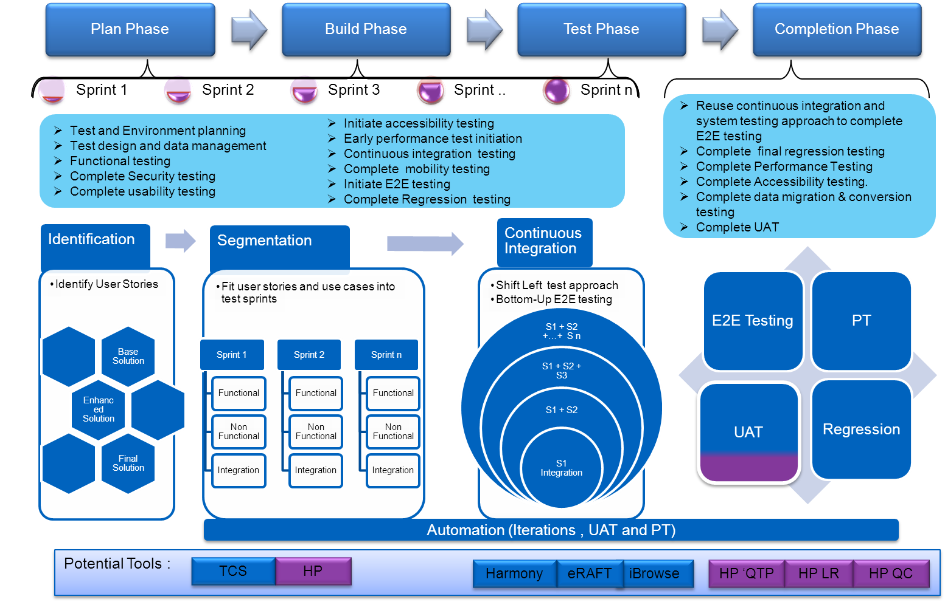

Figure 48: Agile methodology for Assurance

**Shift left Approach**

TCS QA understands that performance testing and End to End testing is a key to this solution considering various channels, products and the roll out needs. Shift left approach is an approach to start the testing as early as possible within the STLC rather to start in the conventional way. The earlier the testing happen the lower the cost for fixing the issues or gaps. Considering this and the need to have complete multi-channel solution and the pressing need to roll out for all releases(geographies) , shift left approach is proposed on Performance testing and E2E testing so the solution that comes out from previous release is tested thoroughly in terms of performance and in terms of functional and integration perspective via E2E.

**Sprint Level & Release level Testing:**

During the Sprints(say two- three weeks), TCS approach is to cover functional testing, regression testing within sprints and to cover non-functional, progressive regression, continuous integration and end-to-end testing outside the sprint window (for previous sprints) as illustrated in Figure below. This is referred as Sprint level testing (inside and outside sprints).

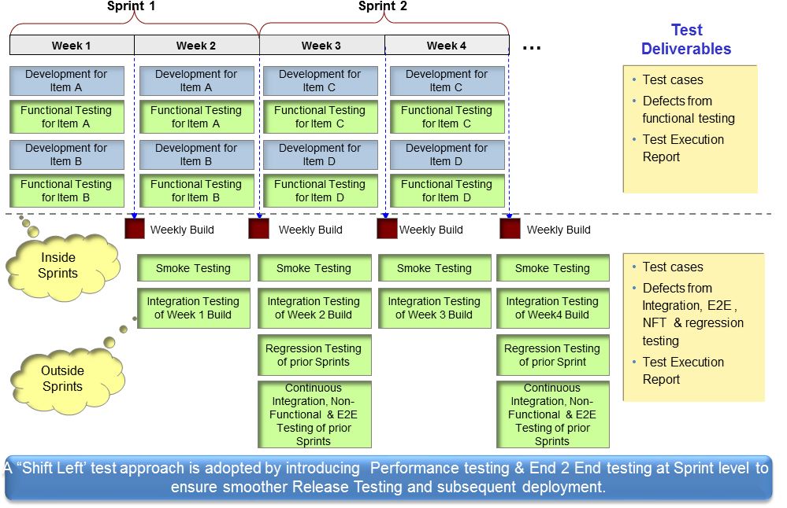

Figure 49: Sprint Level test approach

After the completion of the sprints, completion phase is devised in the approach to test the final release with end to end solution. The final solution of Release 1/Release 2/Release 3/Release 4/Release 5 will undergo End-to-End testing (E2E) to cover all functionalities and integration points , Performance Testing (PT) of the end to end solution, Acceptance testing(UAT) and Operational Acceptance Testing (OAT) prior to the solution deployment. Testing during core testing phase of the end to end solution is referred as Release level testing as in Figure below. (E.g. shown for 2 releases)

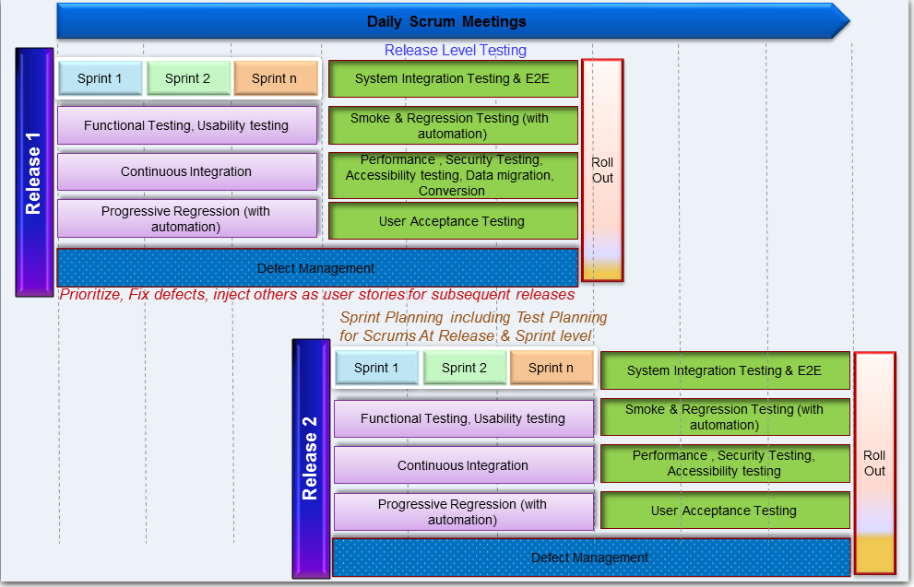

Figure 50: Release level Test Approach

**TCS Assurance Tools and Accelerators**

In addition to the RMCM Channels CoE assets, TCS would extensively leverage the tools and accelerators in the below table for this engagement.

Table 18: TCS testing tools

|  |  |  |  |
| --- | --- | --- | --- |
| **Testing Service** | **Tool** | **Purpose** | **Benefits** |
| **E-Commerce GUI Automation** | e-RAFT | Hybrid test automation framework built on top of HP QTP will be used for automation of functional, regression, continuous integration and E2E testing for this engagement | 30 % Effort reduction in Sprint & Release level testing in Test Automation |
| **Test Case Repository** | e-Harmony | TCS’ re-usable standard Manual and automated Test Cases repository for multi-channel eCommerce testing. This repository will be used to accelerate test case preparation for this engagement | Upto 20% Effort reduction in Test Design/Creation |
| **Browser Compatibility** | i-Browse | Test framework for automation testing of browser compatibility. This tool will be leveraged for browser based testing scenarios | Upto 30% Effort reduction |
| **Performance Testing** | FASTEST | Automated Tool for Performance Testing of Web Apps to save test execution efforts | Upto 20% Effort Reduction during Test Execution phase |
| **Functional Testing** | BVT | A comprehensive cost-efficient Build Verification and Validation framework, BVT runs a standard set of tests on every new release of a product to ensure the regression pack of test cases do not fail due to the changes in the objects of new release, works on QTP | Test Effectiveness increases ensuring improved Test Quality |

* + 1. Delivery Tools

Following are the list of TCS tools which we plan to leverage for this engagement. These are included as part of TCS value added service to HP and license fee is not required:

Table 19: TCS Project management tools

|  |  |
| --- | --- |
| **Tool** | **Benefits** |
| Integrated Estimation Tool (iEST) | Integrated Estimation Tool is to estimate the size, effort, schedule, and cost of an Application Development and Maintenance project |
| Knowledge Management System | KNOWMAX is a platform for collaborating and sharing information across various projects/communities and project teams |
| iCALMS | Integrated Competency and Learning Management System (iCALMS) is a web-based application that facilitates the development and enhancement of employees’ capabilities |
| iPMS | Integrated Project management tool for executing project management activities of planning, tracking, task assignment, reporting, and metrics tracking |